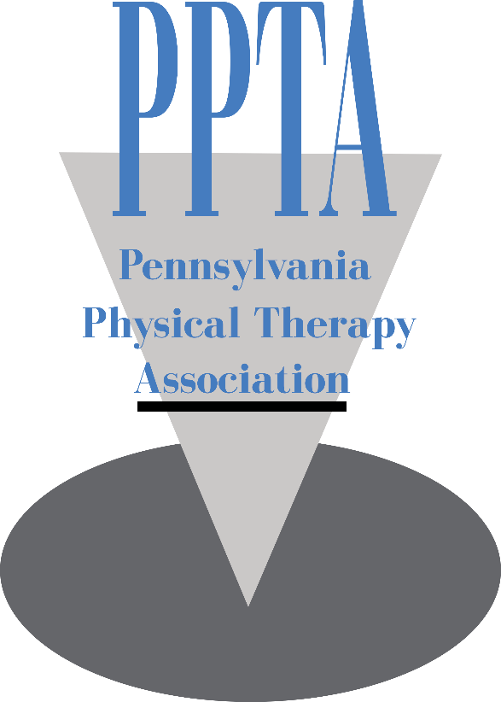

Photo/Video Release Form for Adults

The Pennsylvania Physical Therapy Association (PPTA) has my permission to use my photography or videography publicly in promotions and within on-site displays. I understand that the images and videos may be used in print publications, online publications, presentations, websites, social media and general display. I also understand that no royalty, fee or other compensation shall become payable to me by reason of such use.

Signature: ___________________________________________Date__________

Name: ___________________________________________________________

Phone Number: _____________________________________________________

