Instructions on How to Submit Comments to CMS on the 2021 Physician Fee Schedule Proposed Rule (CMS-1734-P)

- Visit the APTA Regulatory Action Center.
- Scroll down to the CMS Proposed 2021 Physician Fee Schedule and Quality Payment Program Rule summary.
- Find where it states: “Take Action.” You will see next to it a link to submit comments to CMS along with customizable template letters for PTs/PTAs/Students and Patients:

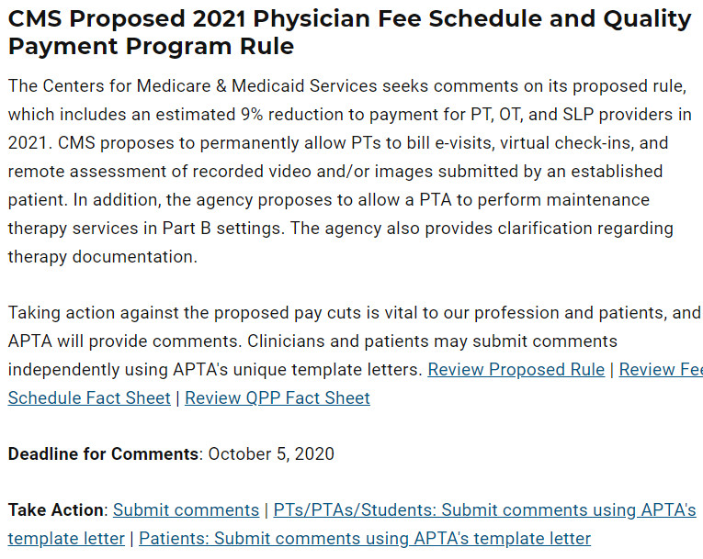

- Download the applicable template letter (word document).
  - Clinicians: Customize the letter and add your personal story regarding HOW the cut will impact you and your patients. Fill in any highlighted “fill in the blank” sections.
  - Clinicians and Patients: Be sure to delete all of the submission instructions at the top.
- Once the letter is final and you’re ready to submit:
- Click on the Submit Comments link.
  - Clinicians: Copy and paste your introductory paragraph into the comment box. Upload your entire comment letter as an attachment. Provide answers to the information being asked (Name, etc.). And then SUBMIT.
  - Patients: Copy and paste your letter into the comment box. You don’t need to upload the letter as an attachment. Provide answers to the other information being asked (Name, etc.). And then SUBMIT.

Questions? Reach out to Kara Gainer at advocacy@apta.org.

